**Activity 1 - Grouping Data**

**Exercise 1**

SELECT

job_id,

COUNT(job_id)

FROM employees

GROUP BY job_id;

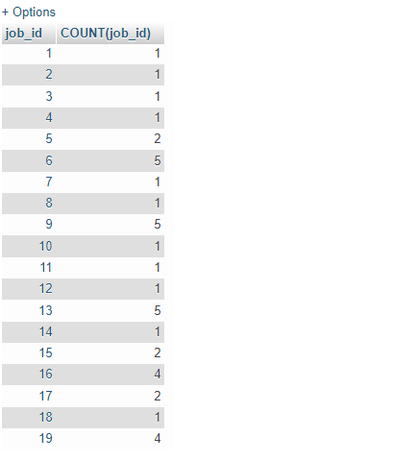

Exercise 2

SELECT

job_id,

COUNT(job_id)

FROM

employees

WHERE

job_id = 9

GROUP BY

job_id;

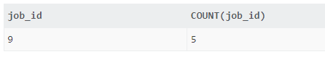

Exercise 3

SELECT

e.job_id,

job_title,

COUNT(employee_id)

FROM

employees e

INNER JOIN jobs j ON j.job_id = e.job_id

GROUP BY e.job_id;

